Farmer-Soldier Problem

Problem : Assignment is to design the solution for m-1 farmers for m soldiers.

Such that 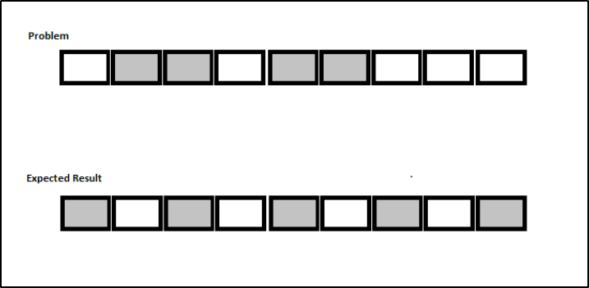

The solution should work for m-n farmers form soldiers. (n>=1 and n<m).

Write an algorithm and derive its order of growth.

Show practical working of you algorithm using C/C++/Java/Python. Step by step showing graphical representation.

Algorithm To Re-Arrange Farmers And Soldiers :

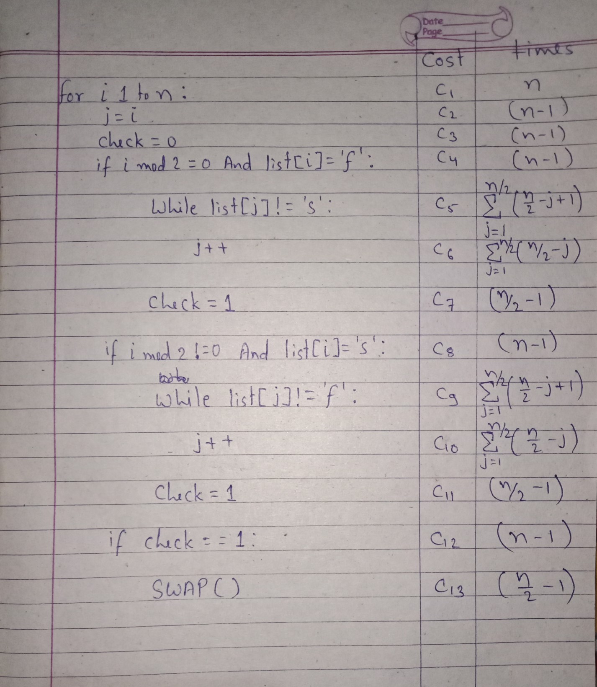

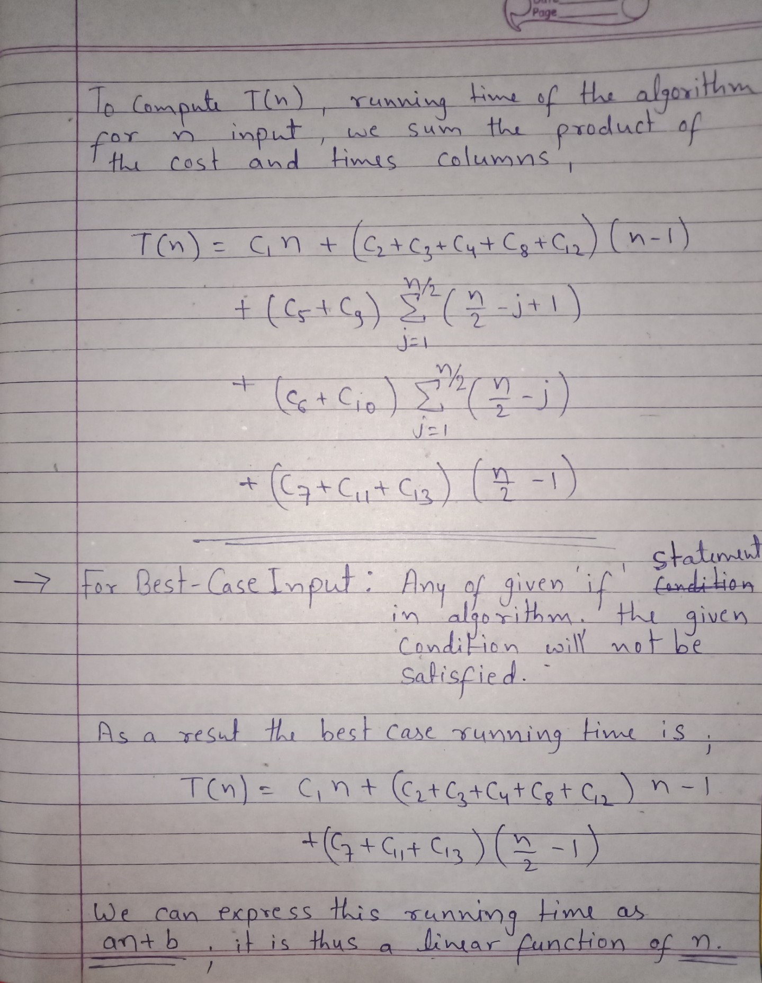

Thus, the algorithm yields on Ω(n) lower bound on the best-case running time i.e. “rate of growth” of running time for best-case input is linear in n.

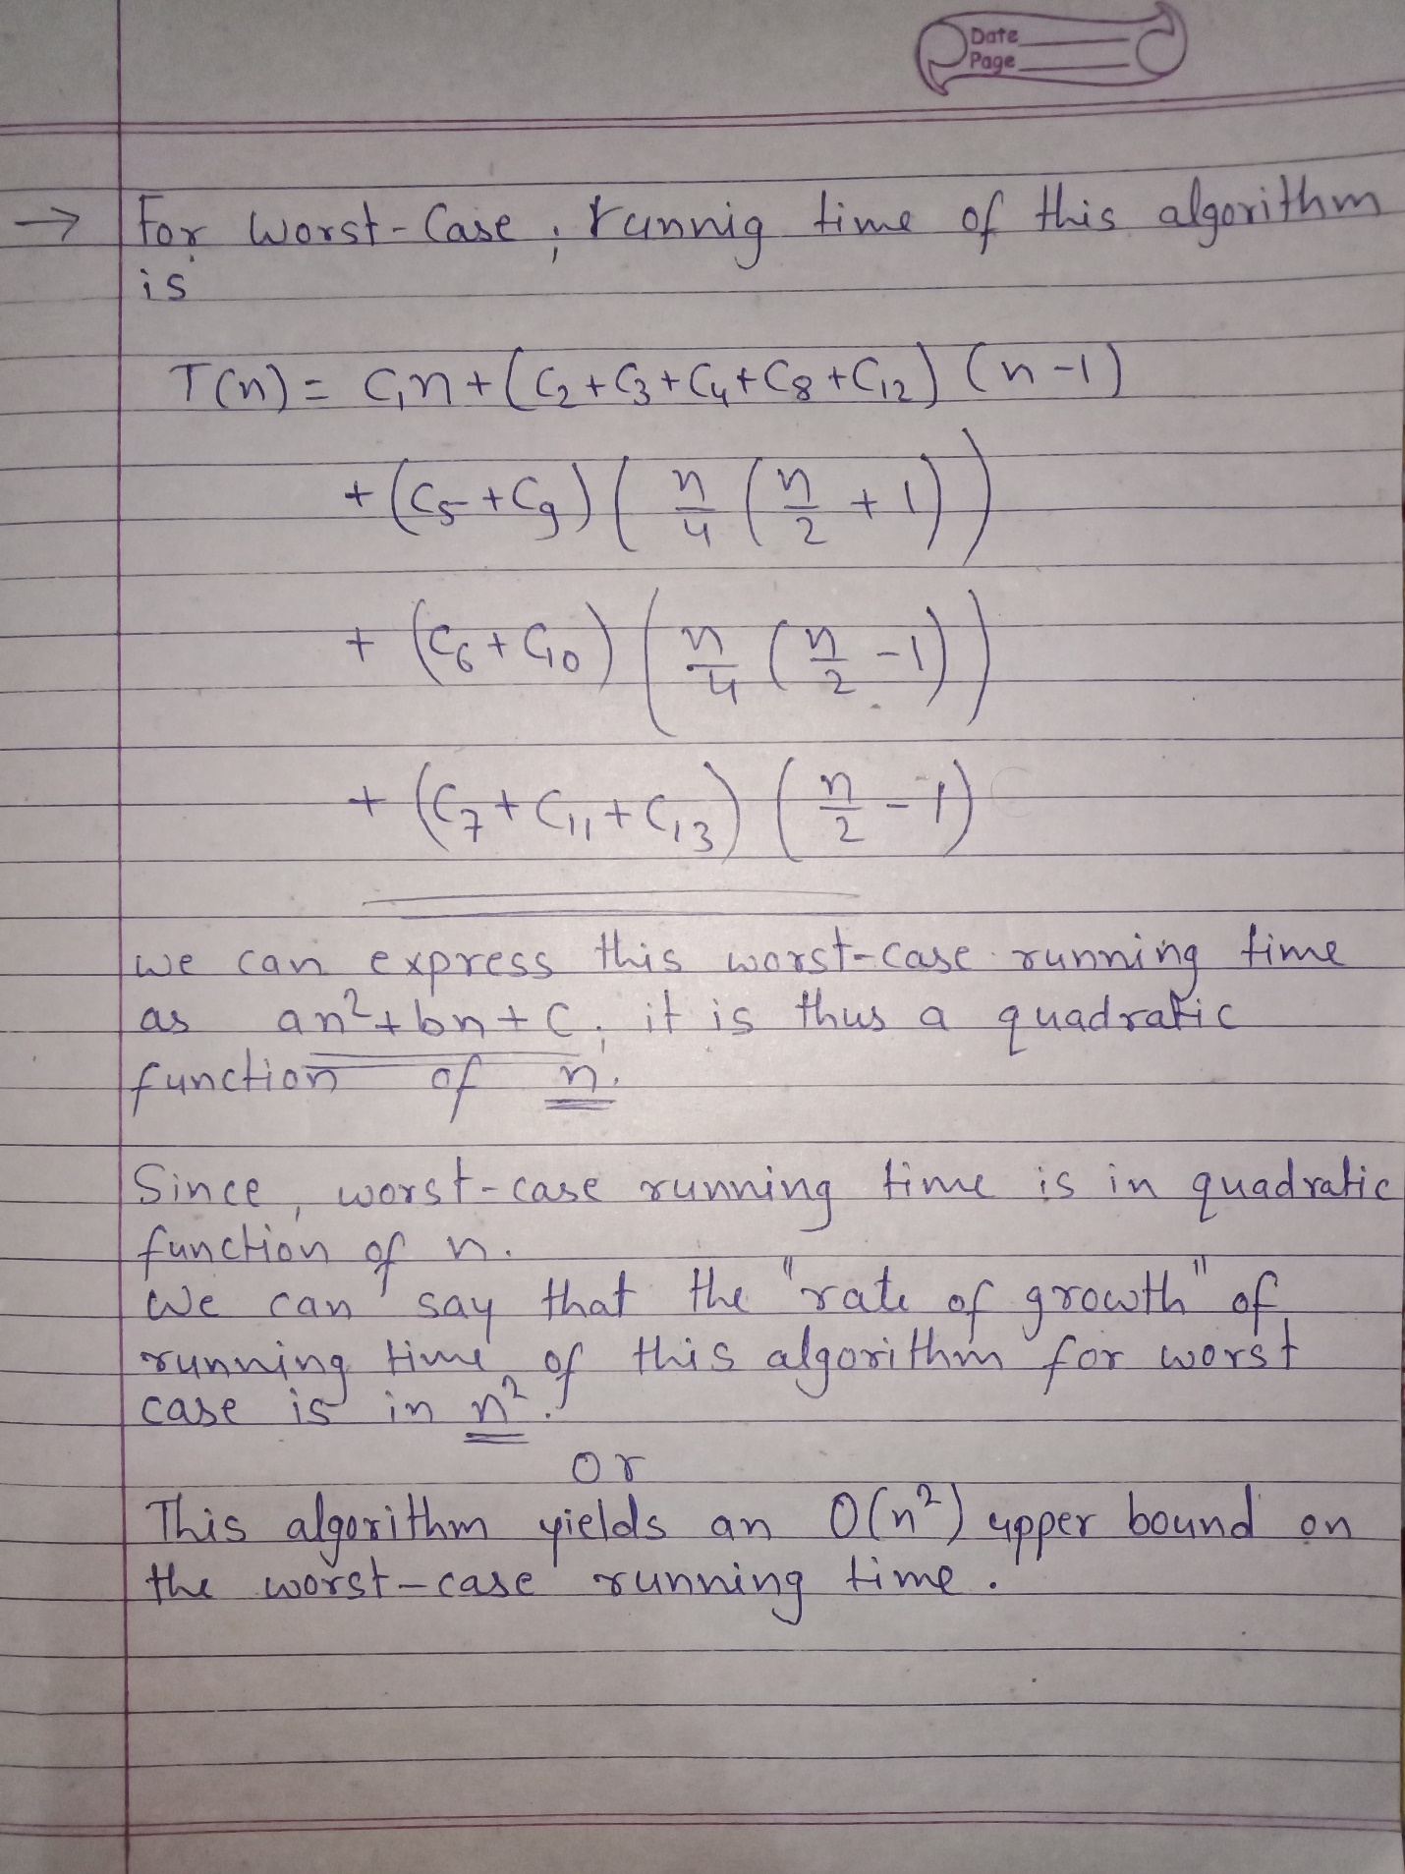

Python Program To Solve Given Problem :

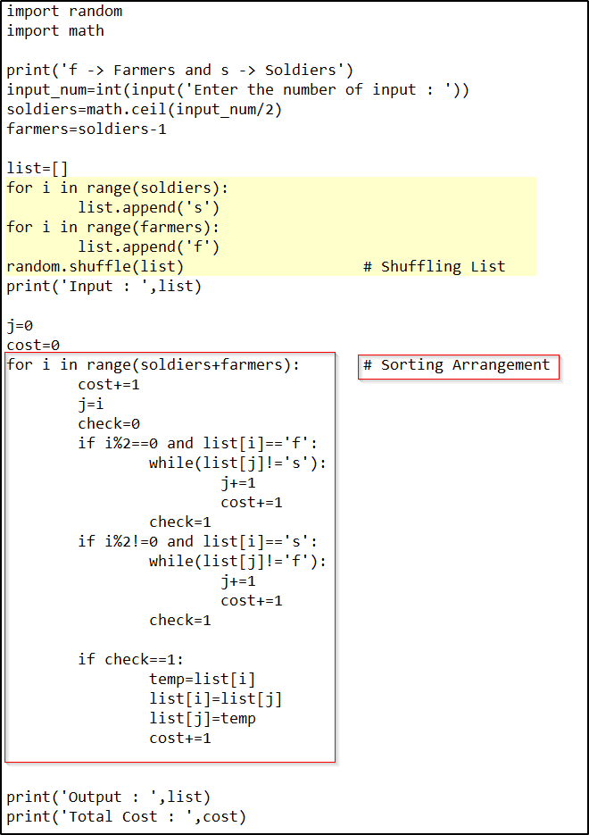

Output :

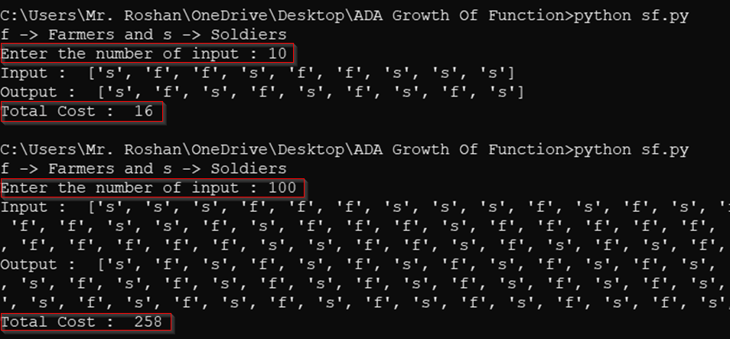

Practical Tests [Upper Bound O(n2)]:

|  |  |  |  |  |
| --- | --- | --- | --- | --- |
| Test | Size | Best | Avg. | Worst |
| 1 | 10 | 9 | 16 | 23 |
| 2 | 100 | 99 | 258 | 1373 |
| 3 | 1000 | 999 | 4913 | 126248 |
| 4 | 10000 | 9999 | 114556 | 12512498 |
| 5 | 100000 | 99999 | 5098586 | 1250124998 |

Smooth-Line Chart (Asymptotic Analysis)